Breakthrough experiment

We performed breakthrough separation experiments to demonstrate the performance of Ni(PyC)2 and Ni(PyC-m-NH2)2 for Xe/Kr mixture (1000 ppm Xe/100 ppm Kr/Ar balance) under dynamic flow conditions while using a flow rate of 10 mL/min. Before breakthrough experiments, two MOFs were pelletized using an FT-IR press using 2k PSI, and particle sizes of 600-850 μm were achieved by using a sieve. The pelletized MOFs were activated at 160 °C in a vacuum oven overnight and packed into a column with a diameter of 6.35 mm and length of 50.8 mm. Approximately 700 mg of MOF was used to fully pack the column. Gas signals were detected using a residual gas analyzer.

As shown in Fig. XX, the Kr quickly came out during the breakthrough after introduction of the gas mixture while Xe was retained in the column for a long time. As we expected, the Ni(PyC-m-NH2)2 shows significantly longer Xe retention time (122 sec) as compared with Ni(PyC)2 (97 sec). When the breakthrough capacities of Ni(PyC-m-NH2)2 and Ni(PyC)2 also were calculated, the Kr capacities were similar in both MOFs (about 1.1 mmol/kg), but the Xe capacities were 18 and 12 mmol/kg, respectively, showing a 60% improvement in Xe capacity for Ni(PYC-m-NH2)2 as compared to Ni(PyC)2.

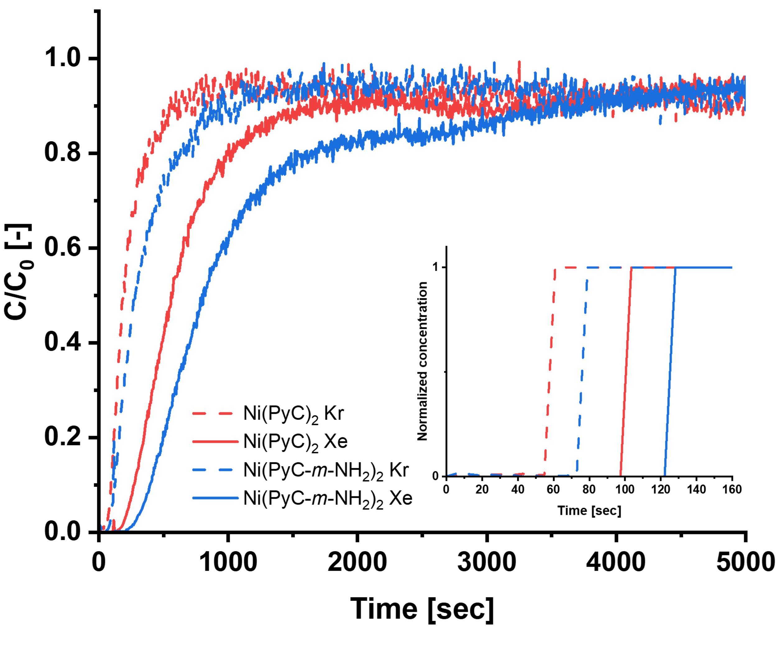

Figure XX. Breakthrough data of Xe and Kr for Ni(PYC)2 (red) and Ni(PYC-m-NH2) (blue). Inset shows normalized concentration of the breakthrough to show when signal of each gas was first detected on RGA.